Remote Access to Dominican Server acatsnew.dom.edu from a MAC. Version 1: July 23, 2016
Please send comments and change requests to me at Jim Miller jmiller@dom.edu.

Major Steps
- Download Microsoft Remote Desktop
- Configure a gateway in Microsoft Remote Desktop
- Define your profile in Microsoft Remote Desktop
- Access the Dominican Server defined in your profile
- Begin working just as if you were at the keyboard of the machine acatsnew.dom.edu

Details

Download Microsoft Remote Desktop
1a. Go to the Apple App Store in you MAC.
1b. Sign in with your Appleid and password if asked.
1c. Search for Microsoft Remote Desktop.
1d. Select Microsoft Remote Desktop Business. You might see two similar looking icons for Microsoft Remote Desktop Business. Make sure to select and download Microsoft Remote Desktop Version 8 (recently 8.0.43). DO NOT SELECT VERSION 10. The rest of these instructions work with Version 8 only. When Version 10 is safe to use, these instructions will be updated.
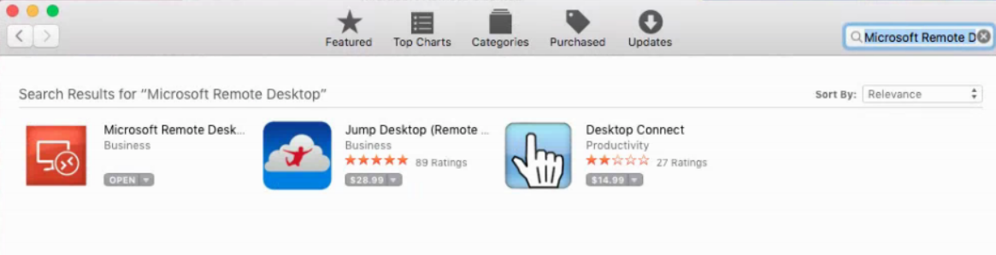
1e. Download and install Microsoft Remote Desktop
1f. Start Microsoft Remote Desktop
1f. Verify that you have release 8.0.43 or later but DO NOT USE VERSION 10
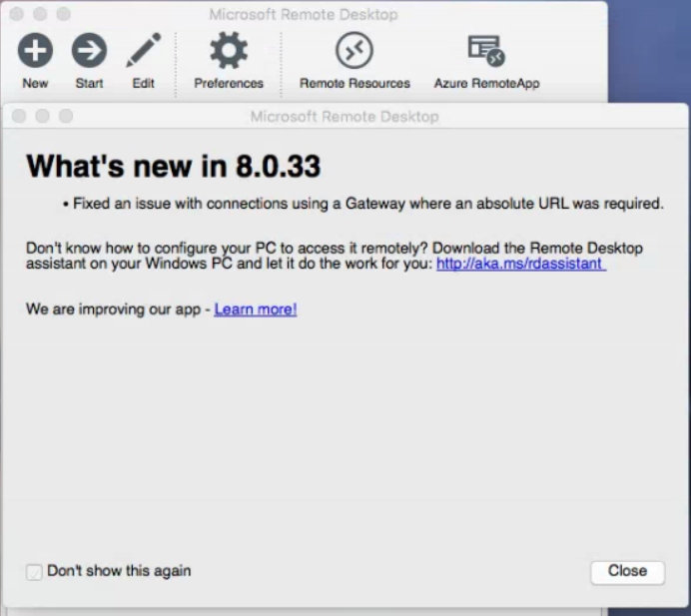

Configure the gateway
2a. Click on Preferences. You will see the screen below. 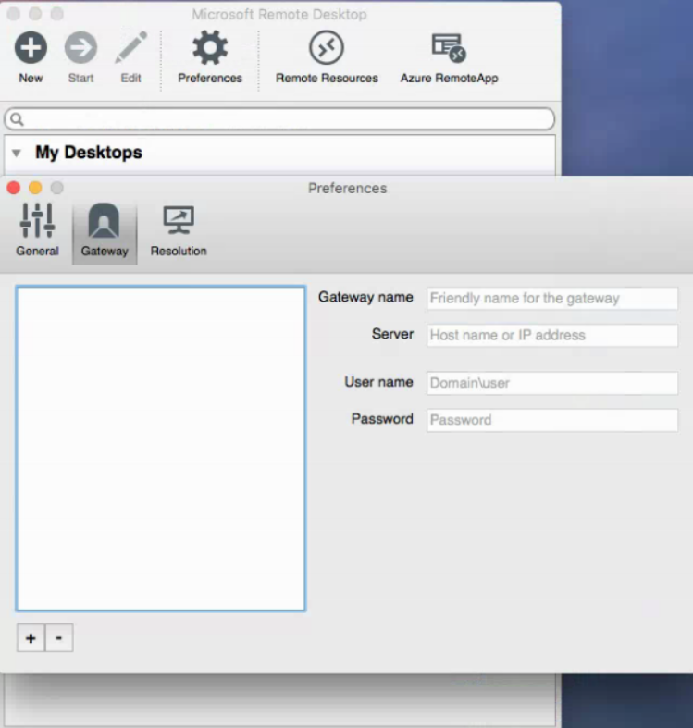

2b. Click on the plus sign at the lower left.
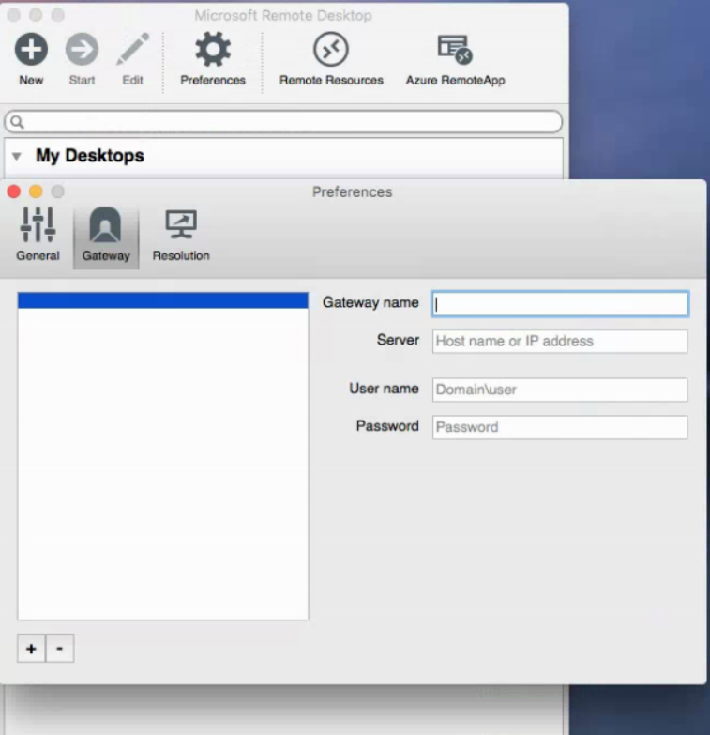

2c. Fill in the information as follows. Gateway name = acatsnew.dom.edu, Server = acatsnew.dom.edu, username = dom\yourusername (for me that would be dom\jmiller), password = yourpassword.
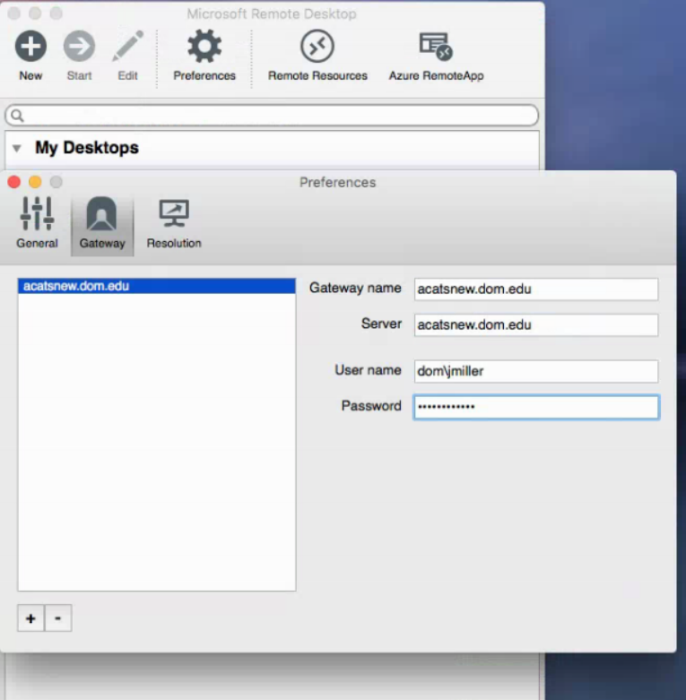
2d. When you have completed all the information, click the red button at the top left of the screen. The gateway has been added although you can’t tell that from the screen that Microsoft displays next.

Define your Profile to Microsoft Remote Desktop

3a. When you see the screen below, Click on “New”.
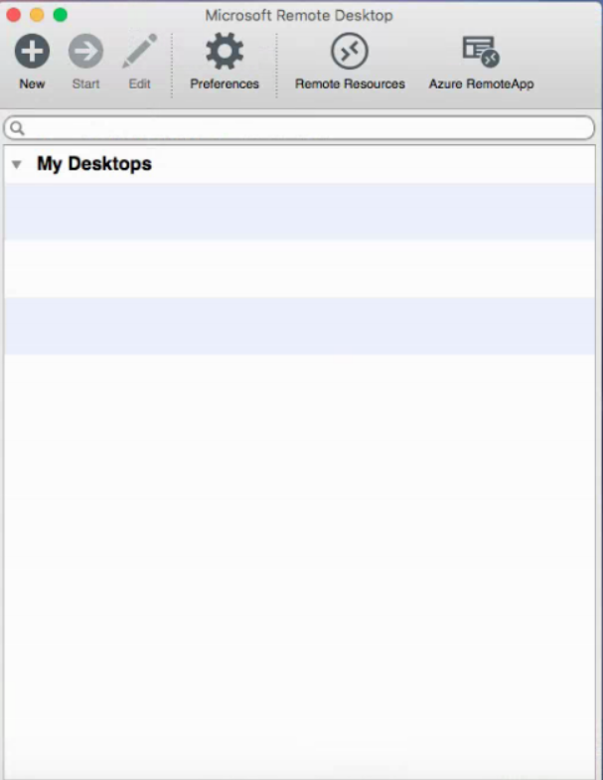

3b. Fill out the screen as shown below. Use your own username and password.
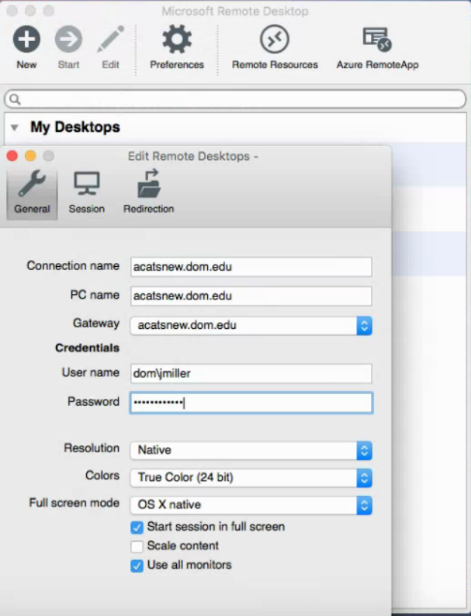
3c. Make sure that Gateway contains acatsnew.dom.edu. Click the red button at the top of the screen after you have completed everything.
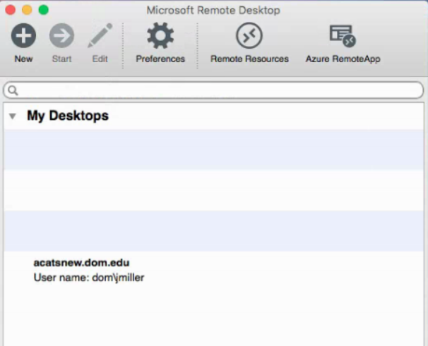

Access the Dominican Server defined in your Profile

4a. Click on the acatsnew.dom.edu entry shown above and you should (after about two minutes) be connected to acatsnew.dom.edu. The messages that you may see during the connection process may include
Connecting …. (may last for well over one minute)
Negotiating Credentials (should go by quickly)
Connecting RDP … (may take a while)
The rest of the messages come from Microsoft Windows on acatsnew. This is a sign you are connected.
Please wait for Windows Group Policy Client
Please wait for Windows User Profile Service.
Note: There might be other messages that went by too quickly for me to see them.
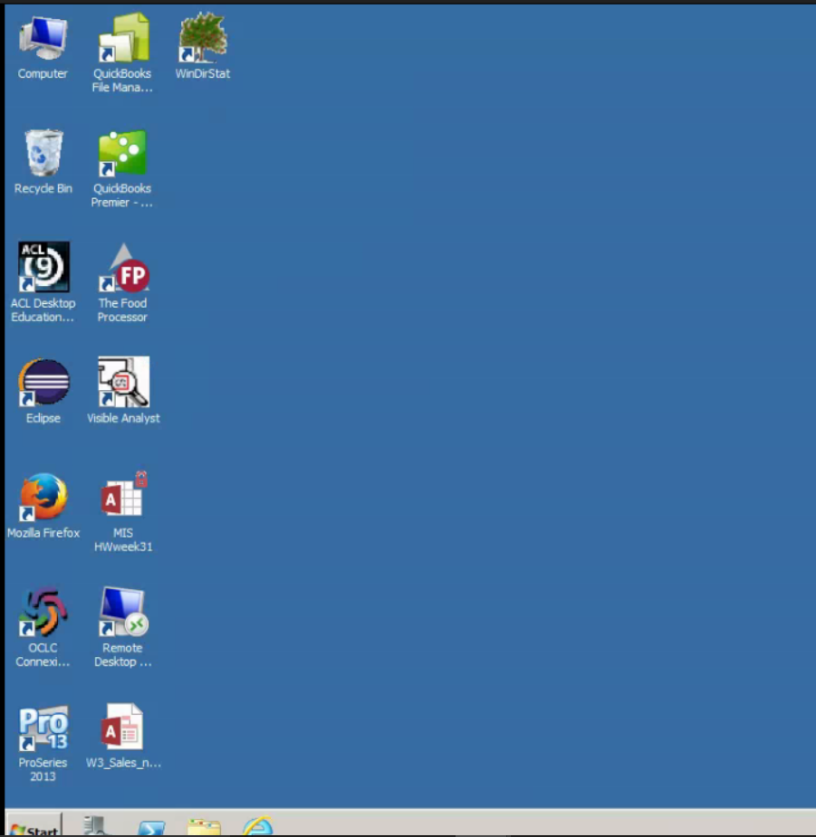

Begin working just as if you were at the keyboard of the machine acatsnew.dom.edu
5a. Start a browser and login to Canvas
5b. Open the homework and download the database you need. You can save it on the desktop of acatsnew.
5c. Do the homework. Double click on the database file that you saved from Canvas. This will open Access and load the database you were given. Add table definitions, data, and diagrams as required. As you are doing this, the database on the desktop is being automatically updated.
5d. Close Microsoft Access. (Do not leave it open or the next step could fail)
5d. Attach the database on the desktop to the homework question in Canvas. Submit the homework.

